**Steps to login for Trailhead using Gmail**

**Step 1:** Copy the below link in your browser, <http://trailhead.salesforce.com/> and click on Sign Up

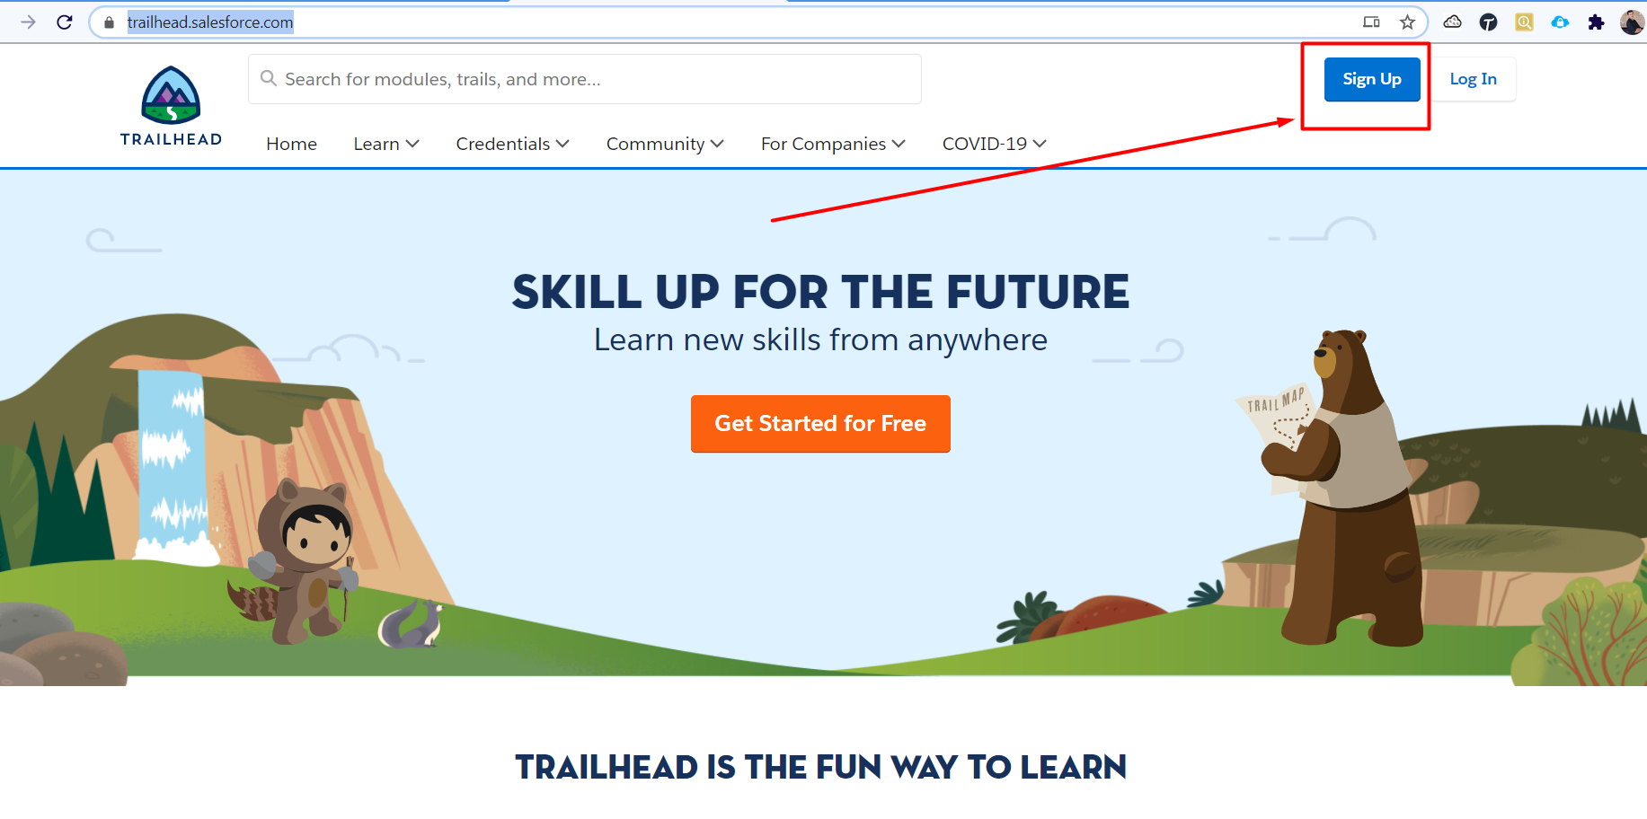

**Step 2:** You will be directed to one more screen click on Google

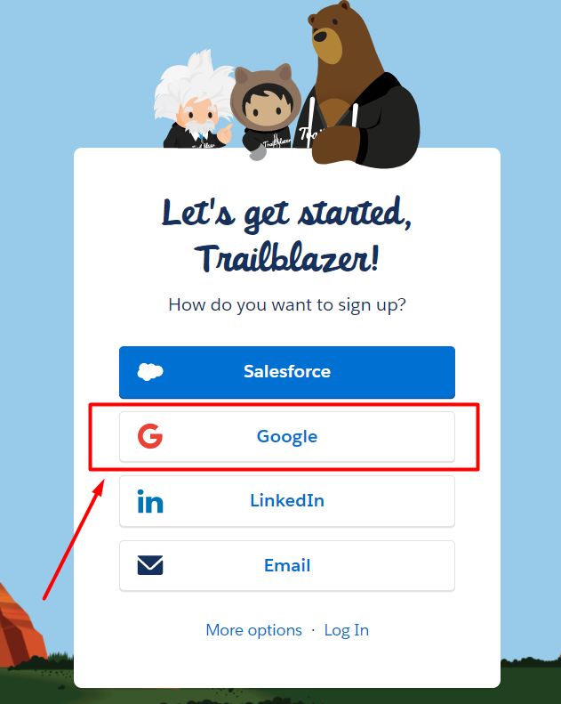

**Step 3:** Select google account which you want to be logged in as

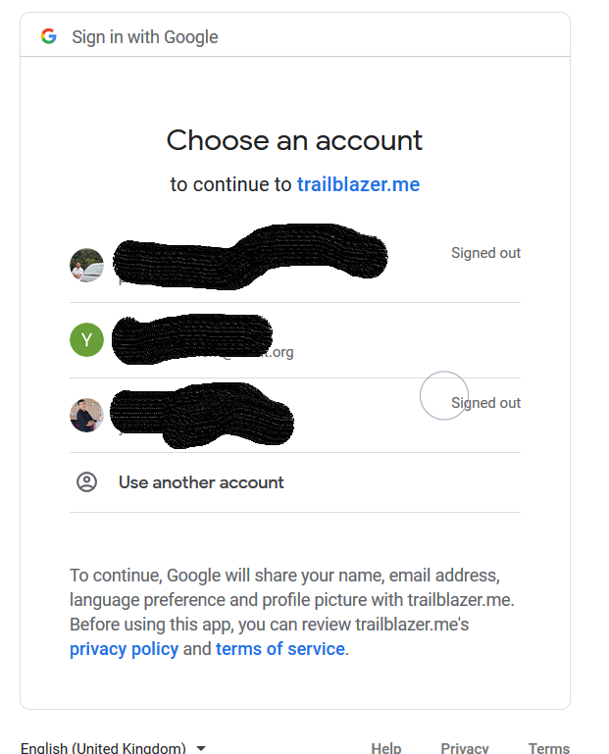

**Step 4:** Fill in all the details

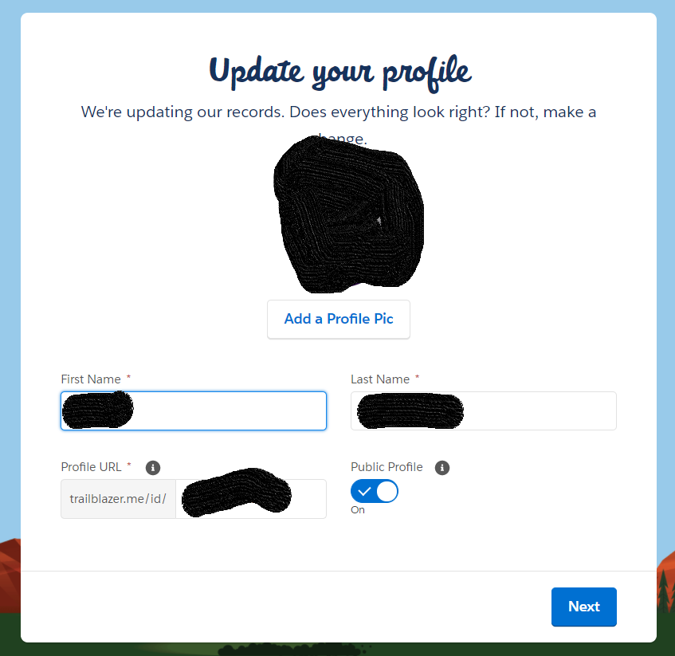

**Step 5:** Fill in All the details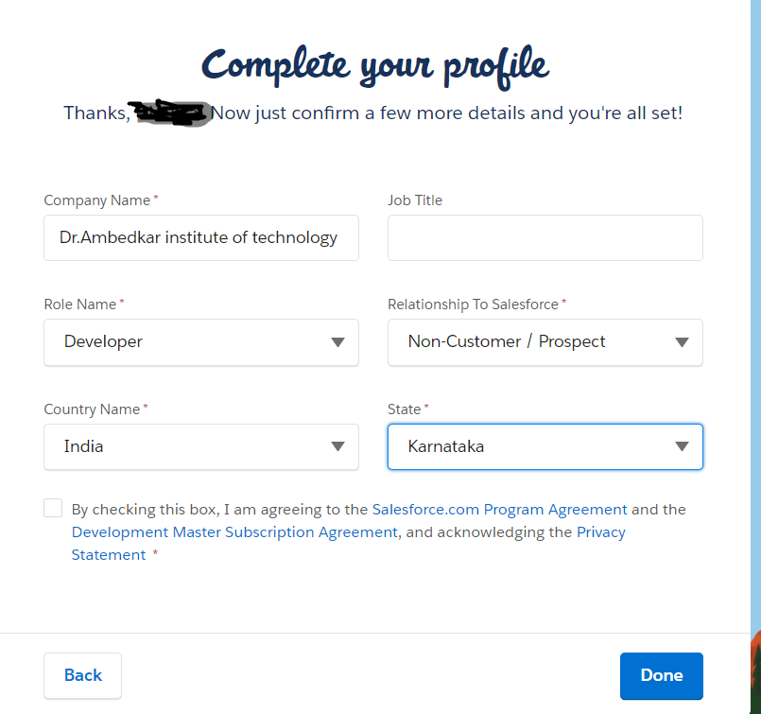

**Step 6:** You are set to rock!!

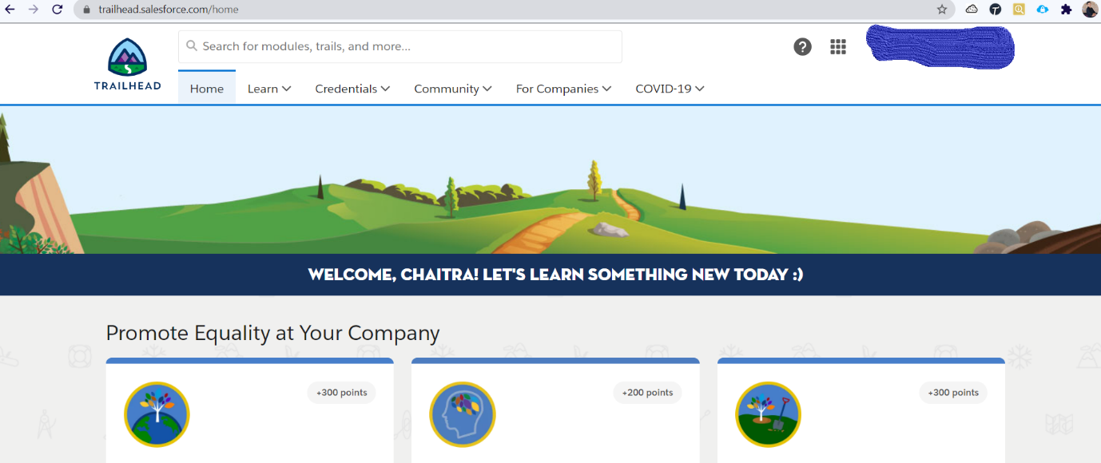

After logging in go to this url and complete all the trailmixes and modules

https://trailhead.salesforce.com/<https://trailhead.salesforce.com/trailblazerconnect>trailblazerconnect

